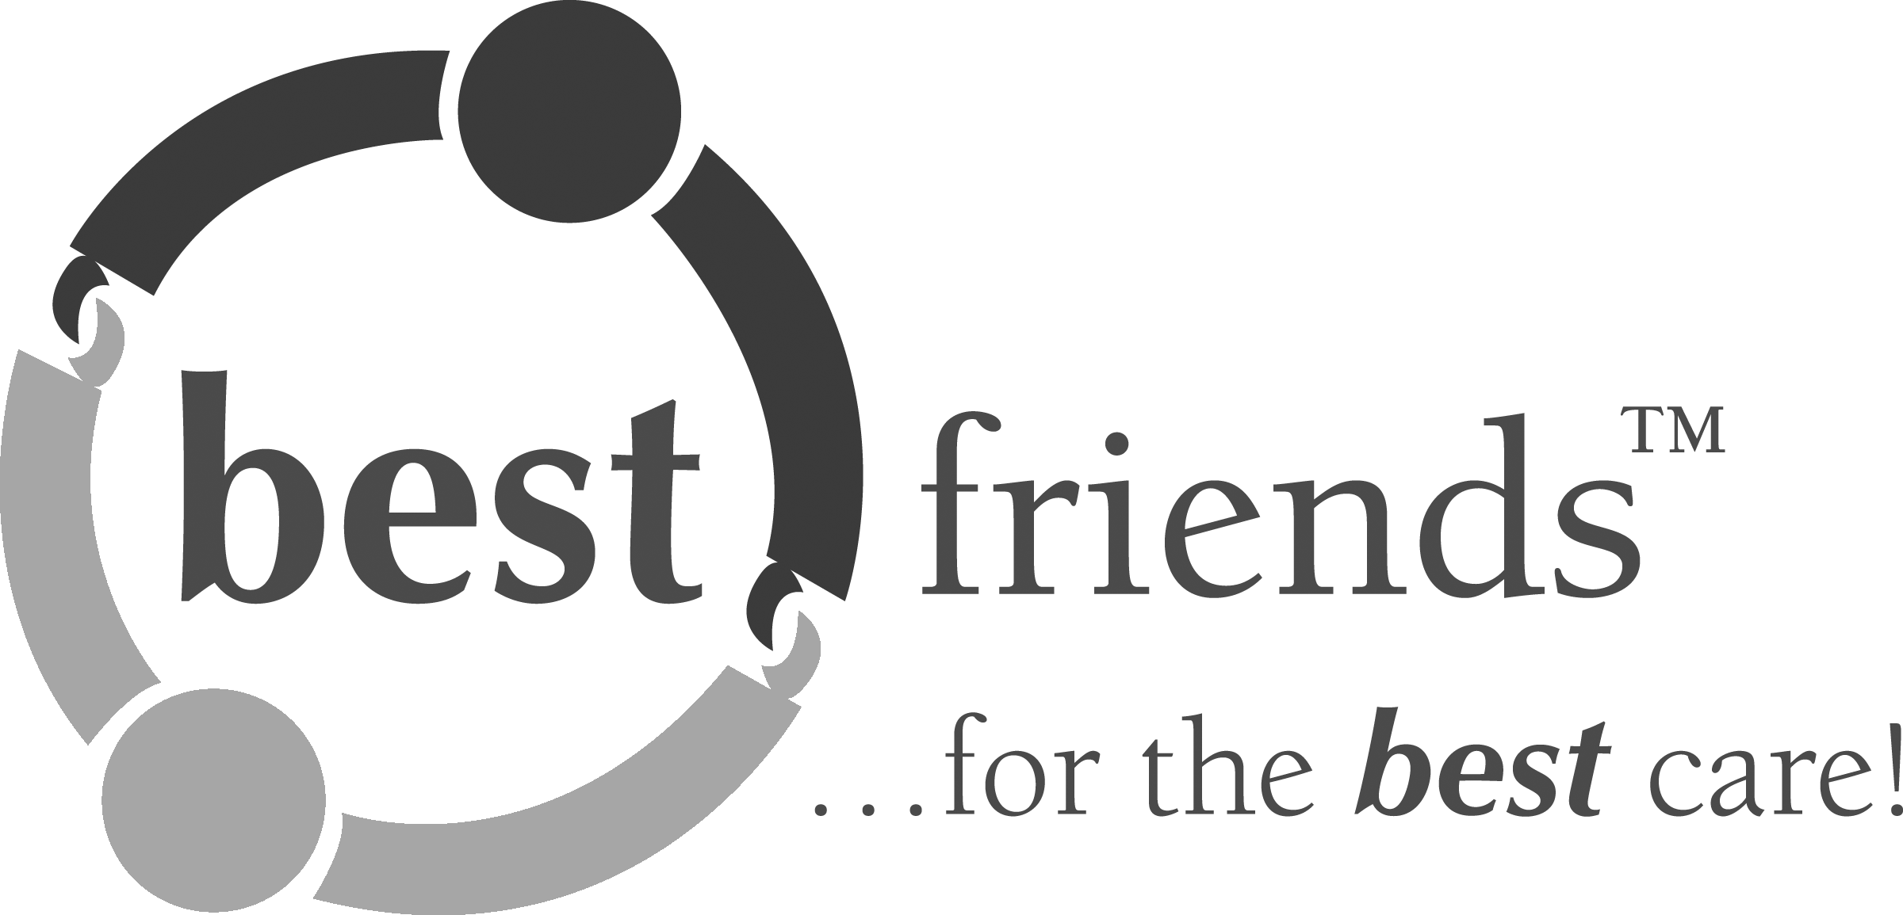 News Release 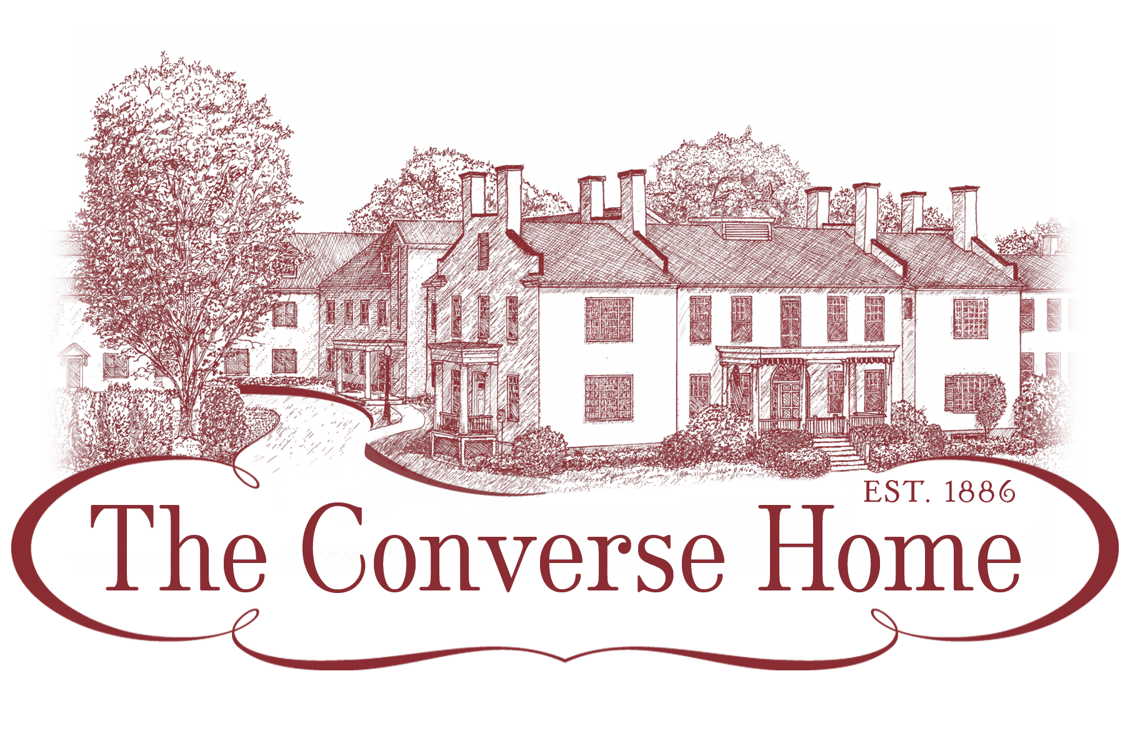

For Immediate Release
Contact: Ellen Meagher, Community Life Director
Best Friends Master Trainer
Phone: 802-862-0401
The Converse Home
Adopts The Best Friends™ Approach to Dementia Care!

Burlington, Vermont, September 16, 2016, The Converse Home adds a Best Friends™ Master Trainer and becomes a certified Best Friends™ Environment. The Best Friends™ Approach is a person-centered, compassionate care philosophy grounded in the understanding that relationships are supremely important to dementia care and that they require the essential elements of friendship: respect, empathy, support, trust, and humor. With Best Friends™, the focus is on the individual—the person’s rights, history, and relationships with all care partners. Adopting this care initiative supports facilities in their quest to create culture-changing communities of care. The core components of the Best Friends™ philosophy include the Dementia Bill of Rights, the Life Story, the KNACK, the art of communication and meaningful programming. Those who have used and endorsed the approach, including internationally recognized dementia experts, state-level agencies, Alzheimer’s Association chapters, and corporations providing care in a variety of settings, have found that the use of this adaptable approach improves the quality of care for the people they serve. More information can be found at bestfriends.healthpropress.com.

The Convers Home’s acquisition of a Certified Best Friends™ Master Trainer demonstrates a commitment to providing the highest quality of dementia care available today as well as to ensuring ongoing, sustainable professional development for staff in the Best Friends™ care philosophy. This qualified individual has demonstrated mastery of the principles and practices of the Best Friends™ Approach to Alzheimer’s care and is the resident expert at her facility with the responsibility of leading co-workers in the provision of this superior, person-centered care model. Maintaining a Master Trainer Certification requires completion of yearly certification standards, which ensure fidelity in ongoing implementation and sustainability.

The Converse Home is currently training all staff working on Gardenview, our memory care community, in the BestFriends approach and will soon branch out to all Converse Home staff. Staff are trained over seven sessions for approximately twelve hours.

